Due November 9, 2018 50% Down on order, Samples on site. 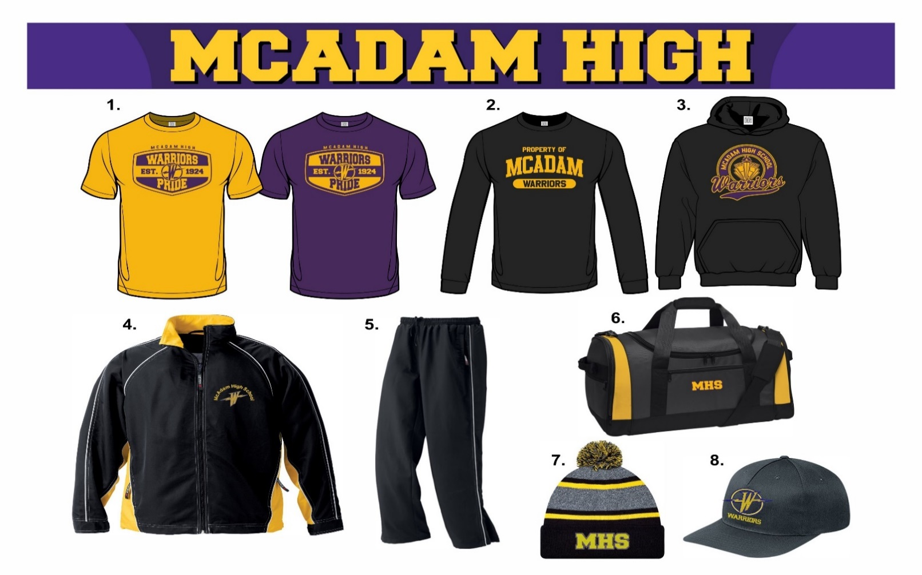

Quantity | Color | Description | Size | Price  (Tax Included) | Total
 | Gold or Purple | - Cotton T-Shirt | Adult S M L XL XXL  Youth S M L | $15.00
 | Black | - Performance Long sleeve | Adult S M L XL XXL  Youth S M L | $23.00
 | Black | - Cotton Hoody | Adult S M L XL XXL  Youth S M L | $30.00
 | Black/Gold | - Track Jacket | Adult S M L XL XXL  Youth S M L | $52.00
 | Black | - Track Pants | Adult S M L XL XXL  Youth S M L | $38.00
 | Black/Gold | - Duffle Bag | One Size | $40.00
 | Black/Gold | - Toque | One Size | $20.00
 | Black | - Hat | One Size | $15.00
 | Gold | Personalization | Left Sleeve | $5.00
 | Gold | Large Name on Track Jacket or Hoody | Lower Back | $10.00

Name/Phone #: _______________________________________________ Total __________________
Personalization Info: __________________________________________________________________

